- Write a program to implement DFS and BFS

Aim
To implement Depth First Search (DFS) and Breadth First Search (BFS) algorithms in Python to traverse the nodes of a graph represented using an adjacency list.
Aim Explanation
Graph traversal is the process of visiting every vertex (node) in a graph.
- Depth First Search (DFS): Traverses the graph by exploring as far as possible along each branch before backtracking. It uses recursion (or a stack).
- Breadth First Search (BFS): Traverses the graph level by level, visiting all neighboring nodes before moving to the next level. It uses a queue.
These algorithms are widely used in path finding, network analysis, web crawling, and AI search techniques.
Algorithm
- Start the program.
- Create the graph using an adjacency list.
- Call the DFS function with the starting node A and display the DFS traversal.
- Call the BFS function with the starting node A and display the BFS traversal.
- End the program.
Program
from collections import deque
# Graph using adjacency list
graph = {
'A': ['B', 'C'],
'B': ['D', 'E'],
'C': ['F'],
'D': [],
'E': ['F'],
'F': []
}
# DFS implementation (using recursion)
def dfs(graph, node, visited=None):
if visited is None:
visited = set()
if node not in visited:
print(node, end=' ')
visited.add(node)
for neighbor in graph[node]:
dfs(graph, neighbor, visited)
# BFS implementation (using queue)
def bfs(graph, start):
visited = set()
queue = deque([start])
while queue:
node = queue.popleft()
if node not in visited:
print(node, end=' ')
visited.add(node)
queue.extend(graph[node])
# Driver code
print("DFS traversal starting from node A:")
dfs(graph, 'A')
print("\nBFS traversal starting from node A:")
bfs(graph, 'A')
Input
The graph is represented as an adjacency list.
graph = {
'A': ['B', 'C'],
'B': ['D', 'E'],
'C': ['F'],
'D': [],
'E': ['F'],
'F': []
}

Graph Representation
A
/ \
B C
/ \ \
D E --> F
Output
DFS traversal starting from node A:
A B D E F C
BFS traversal starting from node A:
A B C D E F
Brief Explanation of the Program
- The graph is stored using a dictionary (adjacency list) where each node contains its neighboring nodes.
- DFS Function
  - Starts from node A.
  - Visits the current node.
  - Recursively visits each unvisited neighboring node.
  - Continues until all reachable nodes are visited.
- BFS Function
  - Starts from node A.
  - Uses a queue (deque) to visit nodes in FIFO order.
  - Visits all neighboring nodes before moving to the next level.
- The driver code calls both DFS and BFS functions and prints their traversal order.

Traversal Order

DFS Traversal
A → B → D → E → F → C
BFS Traversal
A → B → C → D → E → F

2. Write a Program to find the solution for traveling salesman Problem

Aim
To develop a Python program to solve the Traveling Salesman Problem (TSP) using the Brute Force algorithm and determine the minimum-cost tour that visits every city exactly once and returns to the starting city.
Aim Explanation
The Traveling Salesman Problem (TSP) is a well-known optimization problem in computer science. The objective is to find the shortest possible route that starts from a given city, visits all other cities exactly once, and returns to the starting city. The Brute Force approach generates all possible routes (permutations), calculates the total distance of each route, and selects the route with the minimum total cost. Although simple and accurate, this approach is suitable only for a small number of cities due to its high computational complexity.
Algorithm
1. Start.
2. Import the itertools module to generate all possible permutations of cities.
3. Define the function tsp_brute_force(graph, start).
4. Find the total number of cities n from the distance matrix.
5. Create a list of all cities and remove the starting city from the list.
6. Initialize:
- min_cost = ∞ (infinity)
- min_path = None
7. Generate all possible permutations of the remaining cities.
8. For each permutation:
- Create a complete tour by adding the starting city at the beginning and end.
- Set current_cost = 0.
- Calculate the total distance of the tour by adding the distances between consecutive cities.
9. Compare current_cost with min_cost.
- If current_cost is smaller:
  - Update min_cost.
  - Store the corresponding path in min_path.
10. Repeat Steps 8–9 until all permutations are checked.
11. Return the minimum cost path and its total cost.
12. Display the minimum cost path and the total travel cost.
13. Stop.
Program
import itertools
def tsp_brute_force(graph, start):
# Number of cities
n = len(graph)
# All cities except the start
cities = list(range(n))
cities.remove(start)
min_path = None
min_cost = float('inf')
# Try all permutations of cities
for perm in itertools.permutations(cities):
current_cost = 0
current_path = [start] + list(perm) + [start]
# Calculate cost of this path
for i in range(len(current_path) - 1):
current_cost += graph[current_path[i]][current_path[i+1]]
if current_cost < min_cost:
min_cost = current_cost
min_path = current_path
return min_path, min_cost
# Example Distance Matrix (Graph)
graph = [
[0, 10, 15, 20],
[10, 0, 35, 25],
[15, 35, 0, 30],
[20, 25, 30, 0]
]
# Starting from city 0
path, cost = tsp_brute_force(graph, 0)
print("Minimum Cost Path:", path)
print("Total Cost:", cost)
Program Input
graph = [
[0, 10, 15, 20],
[10, 0, 35, 25],
[15, 35, 0, 30],
[20, 25, 30, 0]
]
start = 0
Input Explanation
- The graph is represented as a distance matrix.
- Each element graph[i][j] represents the distance between city i and city j.
- The starting city is City 0.
Program Output
Minimum Cost Path: [0, 1, 3, 2, 0]
Total Cost: 80
Note: Another optimal path such as [0, 2, 3, 1, 0] also has the same minimum cost of 80.
Output Explanation
- The program generates all possible routes starting from City 0.
- It computes the total travel cost for each route.
- The route with the minimum total cost is selected.
- In this example, the shortest route is:
0 → 1 → 3 → 2 → 0
Brief Explanation of the Program
- Import the itertools module to generate all possible permutations of cities.
- Define the function tsp_brute_force(graph, start) to solve the TSP.
- Exclude the starting city and generate all possible visiting orders of the remaining cities.
- For each permutation:
  - Form a complete tour starting and ending at the starting city.
  - Calculate the total travel cost.
- Compare all tour costs and store the path with the minimum cost.
- Return and display the minimum-cost path and its total distance.
3. Write a program to implement Simulated Annealing Algorithm
Aim
To implement the Simulated Annealing (SA) algorithm in Python to find the minimum value of an objective function by using a probabilistic optimization technique inspired by the annealing process in metallurgy.
Explanation of the Aim
Simulated Annealing is an optimization algorithm used to find near-optimal solutions for complex problems. It starts with a random solution and explores neighboring solutions. Initially, it may accept worse solutions to escape local minima. As the temperature decreases gradually, the algorithm becomes more selective and finally converges to the best solution found.
Algorithm
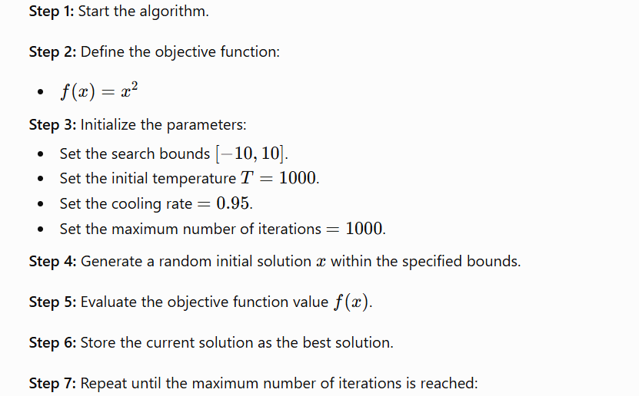
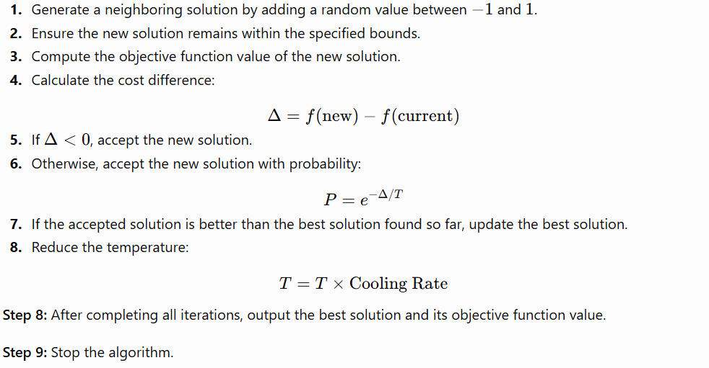
Program
import math
import random
# Objective function: simple quadratic
def objective_function(x):
return x ** 2
# Simulated Annealing Algorithm
def simulated_annealing(objective, bounds, initial_temp, cooling_rate, max_iter):
# Start with a random solution
current_x = random.uniform(bounds[0], bounds[1])
current_cost = objective(current_x)
best_x = current_x
best_cost = current_cost
temperature = initial_temp
for i in range(max_iter):
# Generate a new candidate solution nearby
candidate_x = current_x + random.uniform(-1, 1)
candidate_x = max(min(candidate_x, bounds[1]), bounds[0]) # Clamp to bounds
candidate_cost = objective(candidate_x)
# Calculate acceptance probability
cost_diff = candidate_cost - current_cost
if cost_diff < 0 or random.random() < math.exp(-cost_diff / temperature):
current_x = candidate_x
current_cost = candidate_cost
if candidate_cost < best_cost:
best_x = candidate_x
best_cost = candidate_cost
# Decrease temperature
temperature *= cooling_rate
return best_x, best_cost
# Parameters
bounds = [-10, 10]
initial_temp = 1000
cooling_rate = 0.95
max_iter = 1000
# Run the algorithm
best_solution, best_value = simulated_annealing(objective_function, bounds, initial_temp, cooling_rate, max_iter)
print(f"Best solution: x = {best_solution:.5f}, f(x) = {best_value:.5f}")
In this program, the objective function is:
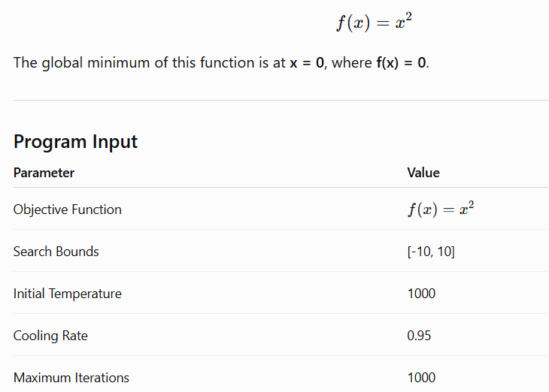

Sample Output
Best solution: x = 0.00231, f(x) = 0.00001
Note: Since the algorithm starts with a random solution, the output may vary each time the program is executed. The solution is expected to be very close to 0.
Brief Explanation of the Program
- The program imports the math and random modules.
- It defines the objective function $f(x)=x^{2}$, which needs to be minimized.
- A random initial solution is generated within the given search bounds.
- A neighboring solution is created by making a small random change to the current solution.
- If the new solution has a lower cost, it is accepted.
- If the new solution is worse, it may still be accepted based on the acceptance probability:
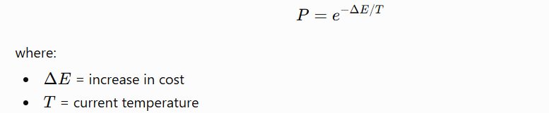
7. The temperature is reduced gradually using the cooling rate after every iteration.
8. The algorithm repeats the process until the maximum number of iterations is reached.
9. Finally, the best solution and its minimum objective value are displayed.

4. Write a program to find the solution for the Wumpus world problem
Aim
To implement the Wumpus World Problem using the Depth First Search (DFS) algorithm in Python to enable an agent to explore the environment and find the gold while avoiding dangerous cells such as the Wumpus and pits.
Aim Explanation
The objective of this program is to simulate a simple Wumpus World environment. The agent starts from a predefined position and uses the Depth First Search (DFS) algorithm to explore neighboring cells. During exploration:
- If the agent reaches a Pit (P) or Wumpus (W), it dies.
- If the agent reaches the Gold (G), the search is successful.
- The program keeps track of visited cells to avoid revisiting the same location.
Algorithm
Step 1: Start.
Step 2: Define the symbols:
- EMPTY = ' '
- PIT = 'P'
- WUMPUS = 'W'
- GOLD = 'G'
- AGENT = 'A'
Step 3: Create a 4 × 4 Wumpus World with the agent, gold, pit, and Wumpus placed in their respective positions.
Step 4: Initialize the agent's starting position.
Step 5: Create a visited matrix and mark all cells as False.
Step 6: Define the four possible movement directions:
- Right
- Down
- Left
- Up
Step 7: Create a function is_valid(x, y) to check whether the cell is inside the grid.
Step 8: Define the recursive DFS(x, y) function:
- If the position is invalid or already visited, return False.
- Mark the current cell as visited.
- If the current cell contains a Pit or Wumpus, display "Agent died" and return False.
- If the current cell contains Gold, display "Gold found. Agent wins!" and return True.
- Explore each neighboring cell recursively using DFS.
- If any recursive call returns True, print the movement path and return True.
- If no path leads to the gold, return False.
Step 9: Start the DFS search from the agent's initial position.
Step 10: If DFS returns False, display "No path to gold found!"
Step 11: Stop.
Program
EMPTY = ' '
PIT = 'P'
WUMPUS = 'W'
GOLD = 'G'
AGENT = 'A'
# Define the world
world = [
[' ', ' ', ' ', 'P'],
[' ', 'W', ' ', ' '],
[' ', ' ', ' ', ' '],
['A', ' ', ' ', 'G']
]
# Agent position
agent_pos = [3, 0]
# Track visited cells
visited = [[False for _ in range(4)] for _ in range(4)]
# Movement directions: Right, Down, Left, Up
moves = [(0, 1), (1, 0), (0, -1), (-1, 0)]
def is_valid(x, y):
return 0 <= x < 4 and 0 <= y < 4
def dfs(x, y):
if not is_valid(x, y) or visited[x][y]:
return False
visited[x][y] = True
if world[x][y] == PIT or world[x][y] == WUMPUS:
print(f"Agent died at ({x}, {y})!")
return False
if world[x][y] == GOLD:
print(f"Gold found at ({x}, {y})! Agent wins!")
return True
for dx, dy in moves:
new_x, new_y = x + dx, y + dy
if is_valid(new_x, new_y) and not visited[new_x][new_y]:
if dfs(new_x, new_y):
print(f"Moved to ({new_x}, {new_y})")
return True
return False
# Start search
print("Starting DFS to find the gold...")
if not dfs(agent_pos[0], agent_pos[1]):
print("No path to gold found!")

Program Input
The input is a predefined 4 × 4 Wumpus World.
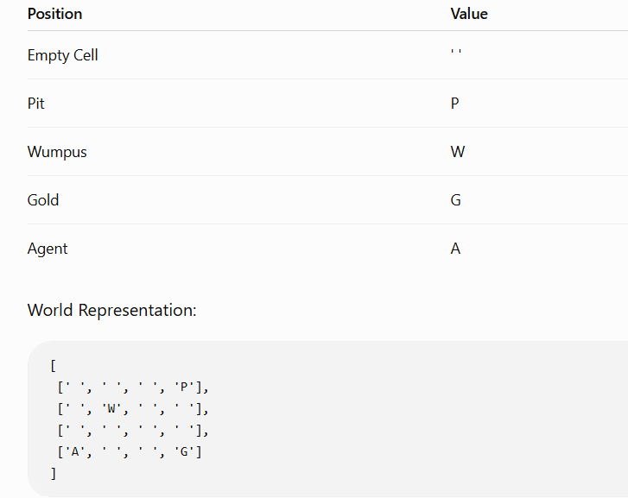
Agent Starting Position:
(3, 0)
Expected Output
Starting DFS to find the gold...
Gold found at (3, 3)! Agent wins!
Moved to (3, 3)
Moved to (3, 2)
Moved to (3, 1)
No path to gold found! (Displayed only if gold is unreachable)
Brief Explanation of the Program
- A 4 × 4 grid is created to represent the Wumpus World.
- The agent starts from the position (3, 0).
- The DFS algorithm explores adjacent cells in the order:
  - Right
  - Down
  - Left
  - Up
- A visited matrix prevents revisiting already explored cells.
- If the agent enters:
  - Pit (P) or Wumpus (W) → the agent dies and that path ends.
  - Gold (G) → the agent successfully finds the treasure and wins.
- If no safe path exists, the program reports that no path to the gold was found.

5. Write a program to implement 8 puzzle problem
Aim
To implement the A* (A-Star) Search Algorithm to solve the 8-Puzzle Problem using the Manhattan Distance heuristic, and to determine the shortest sequence of moves from the initial state to the goal state.
Explanation of the Aim
The objective of this program is to solve the 8-Puzzle Problem, where eight numbered tiles and one blank space are arranged in a 3 × 3 grid. The blank tile can be moved in four directions (up, down, left, or right) to rearrange the tiles.
The A* algorithm is an informed search algorithm that finds the optimal solution efficiently by evaluating each state using:
f(n)=g(n)+h(n)
Where:
- g(n) = Cost from the start state to the current state.
- h(n) = Estimated cost from the current state to the goal state (Manhattan Distance).
- f(n) = Total estimated cost.
The algorithm continues exploring the state with the lowest f(n) value until the goal state is reached.
Algorithm
- Read the start state and goal state.
- Compute the Manhattan distance for the start state.
- Insert the start state into the priority queue.
- Remove the state with the smallest f(n) value.
- If it is the goal state, stop and print the solution.
- Otherwise, generate all valid neighboring states.
- Compute their heuristic values and add them to the priority queue.
- Repeat until the goal state is found or no solution exists.
Program
import heapq
# Manhattan Distance Heuristic
def manhattan_distance(state, goal):
distance = 0
for i in range(1, 9):
x1, y1 = divmod(state.index(i), 3)
x2, y2 = divmod(goal.index(i), 3)
distance += abs(x1 - x2) + abs(y1 - y2)
return distance

# Find neighbors of a state
def get_neighbors(state):
neighbors = []
idx = state.index(0) # position of the blank
x, y = divmod(idx, 3)
moves = [(-1, 0), (1, 0), (0, -1), (0, 1)] # up, down, left, right
for dx, dy in moves:
nx, ny = x + dx, y + dy
if 0 <= nx < 3 and 0 <= ny < 3:
new_idx = nx * 3 + ny
new_state = list(state)
new_state[idx], new_state[new_idx] = new_state[new_idx], new_state[idx]
neighbors.append(tuple(new_state))
return neighbors
# A* Search Algorithm
def a_star(start, goal):
open_list = []
heapq.heappush(open_list, (0 + manhattan_distance(start, goal), 0, start, []))
visited = set()
while open_list:
est_total, cost, current, path = heapq.heappop(open_list)
if current in visited:
continue
visited.add(current)
if current == goal:
return path + [current]
for neighbor in get_neighbors(current):
if neighbor not in visited:
heapq.heappush(open_list, (
cost + 1 + manhattan_distance(neighbor, goal),
cost + 1,
neighbor,
path + [current]
))
return None
# Example usage
start_state = (1, 2, 3,
4, 0, 6,
7, 5, 8)
goal_state = (1, 2, 3,
4, 5, 6,
7, 8, 0)
solution = a_star(start_state, goal_state)
if solution:
print("Solution steps:")
for step in solution:
print(f"{step[0:3]}\n{step[3:6]}\n{step[6:9]}\n")
else:
print("No solution found.")
Program Input
Initial State:
1 2 3
4 0 6
7 5 8
Here,
- 0 represents the blank tile.
Goal State:
1 2 3
4 5 6
7 8 0
Expected Output
Solution steps:
(1, 2, 3)
(4, 0, 6)
(7, 5, 8)

(1, 2, 3)
(4, 5, 6)
(7, 0, 8)

(1, 2, 3)
(4, 5, 6)
(7, 8, 0)

Brief Explanation of the Program
- Manhattan Distance Function
  - Calculates the total distance of each tile from its correct position in the goal state.
  - This serves as the heuristic function h(n).
- Neighbor Generation
  - Finds all possible next states by moving the blank tile (0) in valid directions.
- A* Search
  - Uses a priority queue (heapq) to always expand the state with the lowest estimated cost.
  - Maintains a set of visited states to avoid revisiting them.
  - Continues searching until the goal state is reached.
- Solution Display
  - Prints each intermediate puzzle configuration from the initial state to the goal state.

6. Write a program to implement Towers of Hanoi problem
Aim
To write a Python program to solve the Tower of Hanoi problem using the recursive approach and display the sequence of moves required to transfer all disks from the source peg to the destination peg.
Explanation of the Aim
The Tower of Hanoi is a classic problem that demonstrates the concept of recursion. The objective is to move all the disks from the source peg to the destination peg using an auxiliary peg while following these rules:
- Only one disk can be moved at a time.
- Only the top disk of any peg can be moved.
- A larger disk cannot be placed on top of a smaller disk.
The recursive solution repeatedly moves smaller groups of disks until the entire tower is transferred.
Algorithm
- Start the program.
- Read the number of disks n.
- If n = 1, move the disk directly from the source peg to the destination peg.
- Otherwise:
  - Move n−1 disks from the source peg to the auxiliary peg.
  - Move the nth (largest) disk from the source peg to the destination peg.
  - Move the n−1 disks from the auxiliary peg to the destination peg.
- Repeat the above steps recursively until all disks are moved.
- Stop.
Program
def towers_of_hanoi(n, source, auxiliary, destination):
if n == 1:
print(f"Move disk 1 from {source} to {destination}")
return
# Move n-1 disks from source to auxiliary
towers_of_hanoi(n - 1, source, destination, auxiliary)
# Move the nth disk to destination
print(f"Move disk {n} from {source} to {destination}")
# Move the n-1 disks from auxiliary to destination
towers_of_hanoi(n - 1, auxiliary, source, destination)
Sample Input
Enter the number of disks: 3
Sample Output
Move disk 1 from A to C
Move disk 2 from A to B
Move disk 1 from C to B
Move disk 3 from A to C
Move disk 1 from B to A
Move disk 2 from B to C
Move disk 1 from A to C
Brief Explanation of the Tower of Hanoi Program
This Python program solves the Tower of Hanoi puzzle using recursion.
Program Explanation
Defines a function with:
- n → Number of disks.
- source → Starting rod.
- auxiliary → Helper rod.
- destination → Target rod.
Base Case: If there is only one disk, move it directly from the source rod to the destination rod and stop the recursion.
Recursively moves the top n−1 disks from the source rod to the auxiliary rod using the destination rod as temporary storage.
Moves the largest (nth) disk from the source rod to the destination rod.
- Recursively moves the n−1 disks from the auxiliary rod to the destination rod using the source rod as temporary storage.
Working Principle
The algorithm follows three recursive steps:
- Move n−1 disks from the source to the auxiliary rod.
- Move the largest disk to the destination rod.
- Move the n−1 disks from the auxiliary to the destination rod.

7. Write a program to implement A* Algorithm

Aim
To implement the A* (A-Star) Search Algorithm in Python to find the shortest path between a start node and a goal node in a grid containing obstacles.
Aim Explanation
The A* Search Algorithm is an informed search algorithm used to determine the shortest path between two points. It combines:
- Actual Cost (g): Distance from the start node to the current node.
- Heuristic Cost (h): Estimated distance from the current node to the goal (using Manhattan Distance).
- Total Cost (f):
$$f(n)=g(n)+h(n)$$
The algorithm always selects the node with the smallest f-value, making it both complete and optimal when using an admissible heuristic.
In this program:
- 0 represents a free cell.
- 1 represents an obstacle.
- The algorithm searches for the shortest obstacle-free path from the start position to the destination.
Algorithm
Step 1:
Create a Node class to store:
- Position
- Parent node
- g-cost
- h-cost
- f-cost
Step 2:
Initialize:
- Open List (Priority Queue)
- Closed List (Visited Nodes)
Step 3:
Insert the start node into the open list.
Step 4:
Repeat until the open list becomes empty:
- Remove the node having the smallest f-value.
- If it is the goal node:
  - Trace back using parent nodes.
  - Return the shortest path.
- Otherwise:
  - Generate all valid neighboring nodes.
  - Ignore obstacles and visited nodes.
  - Compute:
    - g = Parent g + 1
    - h = Manhattan Distance
    - f = g + h
  - Insert the node into the open list.
Step 5:
If no path exists, return No Path Found.
Sample Input
grid = [
[0, 0, 0, 0],
[1, 1, 0, 1],
[0, 0, 0, 0],
[0, 1, 1, 0]
]
start = (0,0)
end = (3,3)
Sample Output
Path found:
(0, 0)
(0, 1)
(0, 2)
(1, 2)
(2, 2)
(2, 3)
(3, 3)
Output Explanation
The algorithm starts from (0,0) and explores neighboring cells.
Since some cells contain obstacles (1), they are ignored.
Using the A* evaluation function:
- g(n) = Distance traveled from the start.
- h(n) = Estimated distance to the goal using Manhattan Distance.
- f(n) = g(n) + h(n).
The algorithm always expands the node with the smallest f-value, eventually reaching the goal at (3,3).
The shortest path obtained is:
(0,0)
↓
(0,1)
↓
(0,2)
↓
(1,2)
↓
(2,2)
→
(2,3)
↓
(3,3)
this path successfully avoids all obstacles while minimizing the total travel distance.

8. Write a program to implement Hill Climbing Algorithm
Aim
To implement the Hill Climbing Algorithm in Python to find the maximum value (peak) of a given objective function by iteratively moving toward better neighboring solutions.
Aim Explanation
Hill Climbing is a simple optimization technique used in Artificial Intelligence. It starts from an initial solution and repeatedly moves to a neighboring solution that provides a better objective function value. The process continues until no better neighboring solution is found, indicating that a local maximum (peak) has been reached.
In this program, the objective function is:
$$f(x)=-x^{2}+10x$$
The algorithm starts from x = 0 and moves in small steps of 0.1 until it reaches the maximum value of the function.
Algorithm
- Start with an initial solution x = x_start.
- Calculate the current function value f(x).
- Calculate the function value of the neighboring point f(x + step_size).
- Compare the two values.
  - If the neighboring value is greater, move to the new point.
  - Otherwise, stop because a peak has been reached.
- Repeat Steps 2–4 until:
  - No better neighbor exists, or
  - Maximum iterations are completed.
- Display the final solution and its function value.

Program Input
Input | Value
Objective Function | (f(x) = -x^2 + 10x)
Starting Point | 0
Step Size | 0.1
Maximum Iterations | 1000

Program Output
Peak found at x = 5.0, f(x) = 25.0
Brief Explanation of the Program
- The function hill_climbing() performs the optimization process.
- It starts from the initial point (x = 0).
- In each iteration, it compares the current function value with the value at the next neighboring point (x + 0.1).
- If the neighboring value is higher, it moves to that point.
- The process continues until moving further no longer improves the function value.
- The program then returns the point where the maximum value (peak) is found.
For the function:
$$f(x)=-x^{2}+10x$$
the maximum occurs at:
- x = 5
- Maximum value = 25
Thus, the Hill Climbing algorithm successfully finds the peak of the objective function.

- Build a Chatbot using AWS Lex, Pandora bots.

1. Chatbot Using AWS Lex
AWS Lex is a cloud service provided by Amazon Web Services for building conversational chatbots using Automatic Speech Recognition (ASR) and Natural Language Understanding (NLU). It is the same technology used by Amazon Alexa.
Steps to Build a Chatbot in AWS Lex
- Create an AWS Account
  - Sign in to the AWS Management Console.
  - Open the AWS Lex service.
- Create a New Bot
  - Click Create Bot.
  - Enter a bot name (e.g., StudentAssistant).
  - Select language and voice options.
- Create Intents
  - Intents represent the user's goal.
  - Examples:
    - Greeting
    - BookAppointment
    - CourseInformation
- Define Sample Utterances
  - Example for Greeting intent:
    - "Hello"
    - "Hi"
    - "Good morning"
- Create Slots (Optional)
  - Slots collect user information.
  - Example:
    - Name
    - Date
    - Course Name
- Configure Responses
  - Add messages that the bot will reply with.
  - Example:
    - User: "Hi"
    - Bot: "Hello! How can I help you today?"
- Build and Test the Bot
  - Click Build.
  - Test the chatbot in the AWS Lex console.
- Deploy
  - Integrate with:
    - Website
    - Mobile App
    - Amazon Connect
    - Facebook Messenger
    - Slack
Architecture of AWS Lex
User
|
v
AWS Lex
|
Intent Recognition
|
Business Logic (AWS Lambda)
|
Database/API
|
Response to User

Advantages of AWS Lex
- Easy to develop conversational interfaces.
- Supports voice and text.
- Built-in Natural Language Understanding (NLU).
- Integrates with AWS Lambda and other AWS services.
- Highly scalable and secure.

2. Chatbot Using Pandorabots
Pandorabots is an AI chatbot development platform that uses AIML (Artificial Intelligence Markup Language) to create conversational agents.
Steps to Build a Chatbot in Pandorabots
- Create an Account
  - Sign up on the Pandorabots website.
- Create a New Bot
  - Click Create Bot.
  - Provide a bot name.
- Write AIML Files
  - AIML defines chatbot responses.
Example AIML:
<aiml version="2.0">

<category>
<pattern>HELLO</pattern>
<template>
Hello! Welcome to our chatbot.
</template>
</category>

<category>
<pattern>HOW ARE YOU</pattern>
<template>
I am fine. Thank you!
</template>
</category>

<category>
<pattern>WHAT IS YOUR NAME</pattern>
<template>
My name is SmartBot.
</template>
</category>

</aiml>
4 Upload AIML Files
- Upload the AIML file to the bot.
5 Train the Bot
- Compile the AIML knowledge base.
6 Test the Chatbot
- Open the chat interface.
- Ask questions and verify responses.
7 Deploy
- Integrate using API with:
  - Websites
  - Mobile applications
  - Messaging platforms
Architecture of Pandorabots
User
|
v
Pandorabots Server
|
AIML Knowledge Base
|
Pattern Matching Engine
|
Generate Response
|
User
Advantages of Pandorabots
- Easy to learn using AIML.
- No complex machine learning required.
- Quick chatbot development.
- Supports API integration.
- Suitable for educational and customer support applications.
Applications of Chatbots
- Customer support
- Online shopping assistants
- Banking and finance
- Healthcare
- Educational assistants
- Hotel and travel booking
- HR help desks
- Technical support

  - Build a bot that provides all the information related to your college.

Below is a simple chatbot project that provides information related to a college using Python. You can implement it using rule-based logic or integrate it with platforms such as AWS Lex, Dialogflow, or Pandorabots.
College Information Chatbot
Aim
To build a chatbot that provides complete information about a college, including admissions, courses, departments, fees, placements, faculty, facilities, and contact details.
Features
- College overview
- Admission details
- Courses offered
- Departments
- Fee structure
- Faculty information
- Placement details
- Campus facilities
- Hostel information
- Library details
- Transport facilities
- Contact information
- College timings
Python Implementation

def college_bot():
print("======================================")
print(" Welcome to ABC College Chatbot")
print(" Type 'exit' to quit")
print("======================================")

while True:
user = input("\nAsk your question: ").lower()

if user == "exit":
print("Thank you for visiting ABC College!")
break

elif "college" in user or "about" in user:
print("\nABC College is an autonomous institution established in 2001.")
print("It offers UG and PG programs in Engineering, Science, and Management.")

elif "admission" in user:
print("\nAdmissions are based on entrance examination and merit.")
print("Visit the admission office for complete details.")

elif "course" in user:
print("\nCourses Offered:")
print("- B.E. Computer Science")
print("- B.E. Electronics")
print("- B.E. Mechanical")
print("- MBA")
print("- MCA")

elif "department" in user:
print("\nDepartments:")
print("- Computer Science")
print("- Information Technology")
print("- Electronics and Communication")
print("- Electrical Engineering")
print("- Mechanical Engineering")
print("- Civil Engineering")

elif "fees" in user:
print("\nFee details vary by course.")
print("Contact Accounts Office for updated fee structure.")

elif "placement" in user:
print("\nPlacement Cell:")
print("Highest Package: 12 LPA")
print("Average Package: 4.5 LPA")
print("Top Recruiters: TCS, Infosys, Wipro, Accenture")

elif "hostel" in user:
print("\nSeparate hostel facilities are available for boys and girls.")
print("Wi-Fi, Mess, Security and Medical facilities are available.")

elif "library" in user:
print("\nLibrary contains over 50,000 books, journals, digital library and e-resources.")

elif "transport" in user:
print("\nCollege buses operate from major nearby cities and towns.")

elif "faculty" in user:
print("\nHighly qualified faculty members with Ph.D. and industry experience.")

elif "contact" in user:
print("\nPhone : +91-9876543210")
print("Email : info@abccollege.edu")
print("Website: www.abccollege.edu")

elif "timing" in user:
print("\nCollege Working Hours:")
print("Monday - Friday : 9.00 AM to 4.30 PM")

else:
print("\nSorry! I don't have information about that.")
print("Please ask about admissions, courses, departments, fees, placements, hostel, library, transport, faculty, timings or contact.")
college_bot()

Sample Output
======================================
Welcome to ABC College Chatbot
Type 'exit' to quit
======================================
Ask your question: admissions
Admissions are based on entrance examination and merit.
Visit the admission office for complete details.

Ask your question: courses

Courses Offered:
- B.E. Computer Science
- B.E. Electronics
- B.E. Mechanical
- MBA
- MCA

Ask your question: placements

Placement Cell:
Highest Package: 12 LPA
Average Package: 4.5 LPA
Top Recruiters: TCS, Infosys, Wipro, Accenture

Ask your question: exit

Thank you for visiting ABC College!
Applications
- College websites
- Admission help desks
- Student support systems
- Campus information kiosks
- Virtual assistants for prospective students
Future Enhancements
- Integrate with AWS Lex, Dialogflow, or Pandorabots.
- Connect to a database for real-time updates.
- Support voice-based interaction.
- Add multilingual support.
- Provide AI-based question answering using NLP.
- Integrate with college ERP systems for personalized student services.

11. Build a virtual assistant for Wikipedia using Wolfram Alpha and Python

Aim
To build a virtual assistant that answers user queries using Wolfram Alpha for computational knowledge and Wikipedia for general information.
Requirements
Install the required Python libraries:
pip install wikipedia wolframalpha

Get Wolfram Alpha API Key
- Create an account on the Wolfram Alpha Developer Portal.
- Generate an App ID (API Key).
- Replace "YOUR_APP_ID" in the code with your App ID.

Python Program
import wikipedia
import wolframalpha
# Replace with your Wolfram Alpha App ID
APP_ID = "YOUR_APP_ID"
# Create Wolfram Alpha client
client = wolframalpha.Client(APP_ID)
def virtual_assistant(query):
try:
# Try Wolfram Alpha first
res = client.query(query)
answer = next(res.results).text
print("\nWolfram Alpha Answer:")
print(answer)
except:
try:
# If Wolfram Alpha fails, search Wikipedia
print("\nSearching Wikipedia...")
summary = wikipedia.summary(query, sentences=3)
print("\nWikipedia Summary:")
print(summary)
except wikipedia.exceptions.DisambiguationError as e:
print("\nMultiple results found. Suggestions:")
print(e.options[:5])
except wikipedia.exceptions.PageError:
print("\nNo Wikipedia page found.")
except Exception as e:
print("\nError:", e)
# Main Program
while True:
query = input("\nAsk me anything (or type 'exit'): ")
if query.lower() == "exit":
print("Goodbye!")
break
virtual_assistant(query)

Sample Output
Example 1
Ask me anything (or type 'exit'): What is the speed of light?

Wolfram Alpha Answer:
299,792,458 meters per second
Example 2
Ask me anything (or type 'exit'): Artificial Intelligence

Searching Wikipedia...

Wikipedia Summary:
Artificial intelligence (AI) is intelligence demonstrated by machines,
in contrast to the natural intelligence displayed by humans...

Example 3
Ask me anything (or type 'exit'): Python programming

Searching Wikipedia...

Wikipedia Summary:
Python is a high-level, interpreted programming language known for its
simplicity and readability...

Working
- The user enters a question.
- The assistant first queries Wolfram Alpha.
- If an answer is found, it displays the result.
- Otherwise, it searches Wikipedia and displays a brief summary.
- The process continues until the user types exit.

Applications
- Educational virtual assistant
- Knowledge retrieval system
- Student learning assistant
- General question-answering system
- Computational problem solver
Advantages
- Combines computational and encyclopedic knowledge.
- Easy to implement in Python.
- Provides accurate answers for both factual and mathematical queries.
- Can be extended with speech recognition and text-to-speech features.
Limitations
- Requires an internet connection.
- Wolfram Alpha requires a valid API key.
- Wikipedia may return ambiguous results for broad topics.
- Free API usage may have request limits.
Future Enhancements
- Add voice input using speech_recognition.
- Add voice output using pyttsx3.
- Build a graphical interface using tkinter or PyQt.
- Maintain conversation history.
- Integrate additional knowledge sources for broader coverage.

12. The following is a function that counts the number of times a string occurs in another string: # Count the number of times string s1 is found in string s2 defcountsubstring(s1,s2):
count = 0
for i in range(0,len(s2)-len(s1)+1): if s1 == s2[i:i+len(s1)]:
count += 1 return count
For instance, count substring (’ab’,’cabalaba’) returns 2.
Write a recursive version of the above function. To get the rest of a string (i.e. everything but the first character).
Aim
To write a recursive Python function that counts the number of times a substring occurs in a given string.

Objective
The objective of this program is to demonstrate the use of recursion for solving a string-processing problem by checking each possible position of the main string recursively until the entire string has been examined.

Algorithm
- Start.
- Read the substring s1 and the main string s2.
- If the length of s2 is smaller than the length of s1, return 0 (base case).
- Compare the first len(s1) characters of s2 with s1.
- If they are equal:
  - Return 1 + recursive call on the remaining string (s2[1:]).
- Otherwise:
  - Return the recursive call on the remaining string (s2[1:]).
- Stop when the base case is reached.

Python Program
# Recursive function to count substring occurrences

def countsubstring(s1, s2):
# Base case
if len(s2) < len(s1):
return 0
# Check if substring matches at current position
if s2[:len(s1)] == s1:
return 1 + countsubstring(s1, s2[1:])
else:
return countsubstring(s1, s2[1:])
# Driver code
substring = input("Enter the substring: ")
string = input("Enter the main string: ")
print("Number of occurrences:", countsubstring(substring, string))

Sample Input
Enter the substring: ab
Enter the main string: cabalaba
Sample Output
Number of occurrences: 2

Explanation
- Main string = "cabalaba"
- Substring = "ab"
The recursive function checks each position:
Position | Characters | Match
0 | ca | No
1 | ab | Yes
2 | ba | No
3 | al | No
4 | la | No
5 | ab | Yes
6 | ba | No
Total matches = 2
Brief Explanation of the Program
- The function countsubstring() uses recursion instead of loops.
- The base case occurs when the remaining string becomes shorter than the substring, making further comparisons impossible.
- At each recursive call:
  - It compares the beginning of the current string with the substring.
  - If a match is found, it increments the count by 1.
  - It then calls itself with the remaining string (s2[1:]), effectively moving one character forward.
- The recursion continues until the entire string has been processed.
- Finally, the total number of substring occurrences is returned.

Time Complexity
- O(n × m)
where:
  - n = length of the main string
  - m = length of the substring

13. Higher order functions. Write a higher-order function count that counts the number of elements in a list that satisfy a given test. For instance: count (lambda x: x>2, [1, 2, 3, 4, 5]) should return 3, as there are three elements in the list larger than 2. Solve this task without using any existing higher order function.

Aim
To write a Python program that implements a higher-order function count() which takes a test function and a list as arguments, and counts the number of elements in the list that satisfy the given condition without using any existing higher-order functions such as filter(), map(), or reduce().

Theory
A higher-order function is a function that:
- Accepts another function as an argument, or
- Returns a function as its result.
In this program, the count() function accepts:
- A test function (such as lambda x: x > 2)
- A list of elements
It checks each element in the list using the test function and counts how many elements satisfy the condition.

Program
# Higher-order function to count elements satisfying a condition

def count(test, lst):
c = 0
for item in lst:
if test(item):
c += 1
return c

# Driver code
numbers = [1, 2, 3, 4, 5]

result = count(lambda x: x > 2, numbers)

print("List:", numbers)
print("Number of elements greater than 2:", result)

Sample Input
List = [1, 2, 3, 4, 5]
Condition = x > 2
Sample Output
List: [1, 2, 3, 4, 5]
Number of elements greater than 2: 3

Explanation of program
- The function count() receives:
  - A test function: lambda x: x > 2
  - A list: [1, 2, 3, 4, 5]
- It initializes a counter c to 0.
- It traverses each element in the list using a for loop.
- For each element, it applies the test function.
- If the condition is True, the counter is incremented.
- Finally, the function returns the total count.
Working
Element | Condition (x > 2) | Count
1 | False | 0
2 | False | 0
3 | True | 1
4 | True | 2
5 | True | 3
Therefore, the output is 3.

14. Brute force solution to the Knapsack problem. Write a function that allows you to generate random problem instances for the knapsack program. This function should generate a list of items containing N items that each have a unique name, a random size in the range 1 ....... 5 and a random value in the range 1. 3170. Next, you should perform performance measurements to see how long the given knapsack solver take to solve different problem sizes. You should perform at least 10 runs with different randomly generated problem instances for the problem sizes 10,12,14,16,18,20 and 22. Use a backpack size of 2:5 x N for each value problem size N. Please note that the method used to generate random numbers can also affect performance, since different distributions of values can make the initial conditions of the problem slightly more or less demanding. How much longer time does it take to run this program when we increase the number of items? Does the backpack size affect the answer? Try running the above tests again with a backpack size of 1 x N and with 4:0 x N.

Aim
To implement a Brute Force solution for the 0/1 Knapsack Problem, generate random problem instances, measure the execution time for different input sizes, and analyze how the number of items and backpack capacity affect the algorithm's performance.

Algorithm
- Generate N random items.
- Each item has:
  - Unique name (Item1, Item2, ...)
  - Random weight between 1 and 5
  - Random value between 1 and 3170
- Set backpack capacity.
- Generate all possible subsets of items (Brute Force).
- Find the subset with the highest value without exceeding capacity.
- Measure execution time.
- Repeat for different values of N (10,12,14,16,18,20,22).
- Perform 10 runs for every N.
- Calculate the average execution time.

Python Program
import random
import itertools
import time
# Generate random items
def generate_items(n):
items = []
for i in range(n):
item = {
"name": f"Item{i+1}",
"weight": random.randint(1, 5),
"value": random.randint(1, 3170)
}
items.append(item)
return items
# Brute Force Knapsack
def brute_force_knapsack(items, capacity):
best_value = 0
best_subset = []
n = len(items)
for r in range(n + 1):
for subset in itertools.combinations(items, r):
total_weight = sum(item["weight"] for item in subset)
total_value = sum(item["value"] for item in subset)

if total_weight <= capacity and total_value > best_value:
best_value = total_value
best_subset = subset
return best_value, best_subset

# Performance Testing
problem_sizes = [10, 12, 14, 16, 18, 20, 22]

print("Average Execution Time (10 Runs)")
print("------------------------------------------")
for n in problem_sizes:
capacity = int(2.5 * n)
total_time = 0
for _ in range(10):
items = generate_items(n)
start = time.perf_counter()
brute_force_knapsack(items, capacity)
end = time.perf_counter()
total_time += (end - start)
average = total_time / 10
print(f"N = {n:2d} Capacity = {capacity:2d} Time = {average:.6f} seconds")
Sample Input
Number of Items = 10

Generated Items

Item1 Weight=3 Value=1200
Item2 Weight=2 Value=2100
Item3 Weight=5 Value=980
...
Capacity = 25
Sample Output
Number of Items = 10
Generated Items

Item1 Weight=3 Value=1200
Item2 Weight=2 Value=2100
Item3 Weight=5 Value=980
...
Capacity = 25

Explanation
- Random items are generated with weights between 1 and 5 and values between 1 and 3170.
- The brute-force algorithm checks every possible subset.
- Only subsets whose total weight is less than or equal to the backpack capacity are considered.
- Among these, the subset with the maximum total value is selected.
- The program records the execution time and averages it over 10 runs.
Performance Analysis
Effect of Increasing Number of Items
The brute-force algorithm examines every possible subset.
Number of subsets:
Number of Items (N) | Possible Subsets
10 | 1,024
12 | 4,096
14 | 16,384
16 | 65,536
18 | 262,144
20 | 1,048,576
22 | 4,194,304
The running time increases exponentially as the number of items increases.
Time Complexity:
$$O(2^{N})$$
Does Backpack Size Affect Running Time?
Capacity = 2.5 × N
- The algorithm still checks every subset.
- Capacity only determines whether a subset is accepted or rejected.
- Therefore, execution time changes only slightly.

Testing Different Backpack Sizes
Run the same experiment using:
- Capacity = 1 × N
- Capacity = 4 × N

Example:
capacity = n # 1 × N

capacity = int(2.5*n) # 2.5 × N

capacity = 4*n # 4 × N

Observation
- Capacity = 1 × N: Fewer subsets satisfy the weight constraint, but the algorithm still evaluates every subset.
- Capacity = 4 × N: More subsets satisfy the constraint, but the algorithm still evaluates every subset.
Thus, the backpack size has very little effect on the running time of the brute-force algorithm because every subset is generated and checked regardless of the capacity.

15. Assume that you are organising a party for N people and have been given a list L of people who, for social reasons, should not sit at the same table. Furthermore, assume that you have C tables (that are infinitely large). Write a function layout (N,C,L) that can give a table placement (i.e. a number from 0 : : :C -1) for each guest such that there will be no social mishaps. For simplicity we assume that you have a unique number 0 ......N-1 for each guest and that the list of restrictions is of the form [(X, Y) ...] denoting guests X, Y that are not allowed to sit together. Answer with a dictionary mapping each guest into a table assignment, if there are no possible layouts of the guests you should answer False.

Aim
To write a Python function layout(N, C, L) that assigns N guests to C tables such that no two guests who are not allowed to sit together are assigned to the same table. If no valid arrangement exists, the function returns False.

Algorithm
- Represent each guest as a node.
- Build an adjacency list from the restriction list L.
- Assign tables to guests one by one using backtracking.
- For each guest:
  - Try every table from 0 to C-1.
  - Check whether any restricted guest is already sitting at that table.
  - If safe, assign the table and continue.
- If all guests are assigned successfully, return the dictionary.
- If no assignment is possible, return False.

Python Program
def layout(N, C, L):
# Create adjacency list
graph = {i: [] for i in range(N)}
for x, y in L:
graph[x].append(y)
graph[y].append(x)
assignment = {}
# Check if assigning table is safe
def is_safe(guest, table):
for neighbor in graph[guest]:
if assignment.get(neighbor) == table:
return False
return True
# Backtracking function
def solve(guest):
if guest == N:
return True
for table in range(C):
if is_safe(guest, table):
assignment[guest] = table

if solve(guest + 1):
return True
del assignment[guest]
return False
if solve(0):
return assignment
else:
return False

# Example
N = 5
C = 2
L = [(0, 1), (1, 2), (2, 3), (3, 4)]

result = layout(N, C, L)

print("Table Assignment:", result)

Sample Input
Number of Guests (N) = 5
Number of Tables (C) = 2

Restrictions:
[(0,1), (1,2), (2,3), (3,4)]

Sample Output
Table Assignment:
{0: 0, 1: 1, 2: 0, 3: 1, 4: 0}
Sample Input 2
N = 3
C = 2
L = [(0,1), (1,2), (2,0)]
Sample Output 2
False
Brief Explanation
- The problem is equivalent to a graph coloring problem.
- Each guest is treated as a vertex, and each restriction is an edge.
- Each table represents a color.
- The algorithm uses backtracking to assign a valid table to every guest.
- If every guest can be assigned without violating any restriction, a dictionary containing guest-to-table assignments is returned.
- If no valid arrangement exists with the available tables, the function returns False.
Time Complexity
- Worst Case: $O(C^{N})$, where:
  - $N$= Number of guests
  - $C$= Number of tables

